***323-guruh talabasi***

***Ergashova Sevaraning***

***My favourite hobby is…***

mavzusida 1 soatlik

**Dars ishlanmasi**

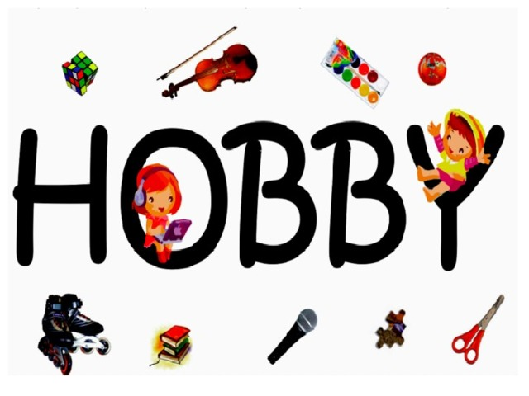

**Date_____ Form_____ Subject: English**

**Theme: My favourite hobby is…**

**Aims:**

***Educational****:* - to practise talking about leisure activities

***Developing:*** - to practise listening for specific information

- to practise reading information in tables

- to practise talking about most popular and least popular activities using the superlative

***Socio-cultural:*** - to raise awareness of spending time more useful with hobbies.

***Up bringing****:* - to enrich pupils’ knowledge of saving times with useful activities

***Learning outcomes:*** At the end of the lesson pupils will be able to talk about their hobbies and activities that they spend in their spare time.

***Competence:*** SC1, FLCC, and PC

***Type of the lesson:*** Mixed, group work, pair-work, individual work

***Method of the lesson:*** nontraditional, mixed

***Equipment of the lesson:*** Textbook “Teen’s English 7”, pictures, internet, computers, projector

**TECHNOLOGICAL MAP OF THE LESSON:**

|  |  |  |  |
| --- | --- | --- | --- |
| **№** | **Part of the lesson** | **Tasks** | **Time** |
| 1 | Organizational  Moment | -to greet pupils.  - to check up the register | 5 min |
| 2 | Repeating last lesson | - to give pupils some questions about last lesson. – to ask words from previous lesson | 5 min |
| 3 | Explaining new theme | - to explain to pupils new vocabulary and theme | 20 min |
| 4 | Consolidating new theme. | - to consolidate new theme and new words of the theme. | 10 min |
| 5 | Marking. | - To mark pupils | 5 min |
| 6 | Homework. | - Giving homework. |

**Procedure of the lesson:**

***I. Organizing moment:*** Motivation,Greeting, checking attendance, season, weather, checking the preparation for the lesson.

***II. Asking homework:***

- Check for homework given on past lesson.

- Ask pupils all new words learnt on previous lesson.

***III. Pre-activity:***

**Activity 1**

**Objectives: • to revise vocabulary from the 5th form; to introduce and practise some new words**

PP look at the labels and guess the meaning of the new words. Teach the pronunciation of the new words. Ask PP to say the meaning of the words in their mother tongue. Then ask them to make sentences using a verb and appropriate noun as in the example:

*I like playing the dutar*, etc.

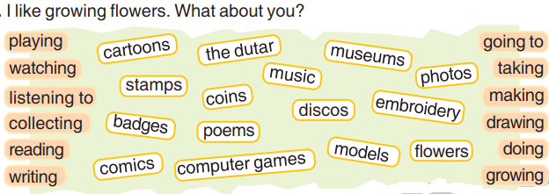

***IV. Main part***

**Activity 2**

**Objective: • to practise listening for specific information**

PP copy the num bers 1-3 in their Ex.Bks. PP look at the photo of Nodira

and her coins and read the 3 questions and write the answers. Ask them who they can see, what Nodira is holding. Then PP listen to the tape and check their guesses. Then ask them what they think are the most popular leisure activities in Uzbekistan for boys and girls. Then they can try to guess the most popular ones in Britain too.

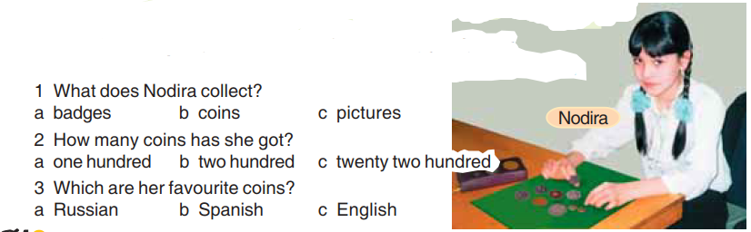

**Tapescript**

|  |
| --- |
| Interviewer: Nodira, W hat’s your hobby?  Nodira: I collect coins you know, coins from different countries.  I: Mmm... you collect coins. And how many have you got?  N: About two hundred, yes, tw o hundred I think.  I: Where do you find them?  N: Well, my father goes to different countries for his work, you know. He  gives me them. And when we go on holiday to other countries I always  get some coins.  I: Where do you keep your coins?  N: In beautiful albums. W ould you like to see them?  I: Wow! They’re beautiful. You’ve got a lot, haven’t you? And which are  your favourite coins?  N: Er... I think the English coins are, yes, the English ones especially the  one with seven sides ... the 20 pence coin.  I : Have your friends got coins?  N: No, they don’t collect coins, they collect other things.  I: Thank you, Nodira. |

**Key:** 1b 2b 3c

**Activity 3**

**Objectives: • to practise reading information in tables; to practise talking about most popular and least popular activities using the superlative**

Ask PP to read the table and com plete the sentences in their Ex.Bks.

