Lesson plan: **global warming class 11**

# subject: english date:02/12/2022

**The Theme of the lesson :** global warming / Глобальное потепление.

**The aims of the lesson**: learn new vocabulary related to the topic

**Upbringing aim**: to educate pupils to save environment. Give some agreements about environment. Make strong opinion about global warming

**Developing aim:** to develop pupil’s skills and habits of reading, listening, writing, their oral speech and pronunciation.

**The Method of the lesson:** direct method and grammar translation method

**The Type of the lesson**: skill based learning

**The Equipment of the lesson:** English book, vocabulary, dictionary, pictures, posters.

**The Procedure of the lesson**: Interaction { greeting with students and check attendance}

Doing warm up for activating students: peer banana .

**The Main part of the lesson**: introduce new topic and give instructions for ex and tasks.

A; giving definition for new words diverse ex

b ; work with language skills listening, speaking

c ; revise the topic vocabulary

**End of leeson**: *Wrap up* : TIME IS UP , give hometask , applause them selves for participating.

***Dars jarayonidagi mashqlar quyida keltirildi:***

**Warm up peer banana :** peer banana 2 times , chop banana 2 t , eat banana 2 t , drink banana, shake banana 2t { bu mashq harakatlar orqali sozlarni takrorlash uchun foydali}

**New vocabulary of the topic / mavzuga doir so’zlar**

2 speaking part causes and effects of **deforestation [ daraxtlarni kesib tashlash]**

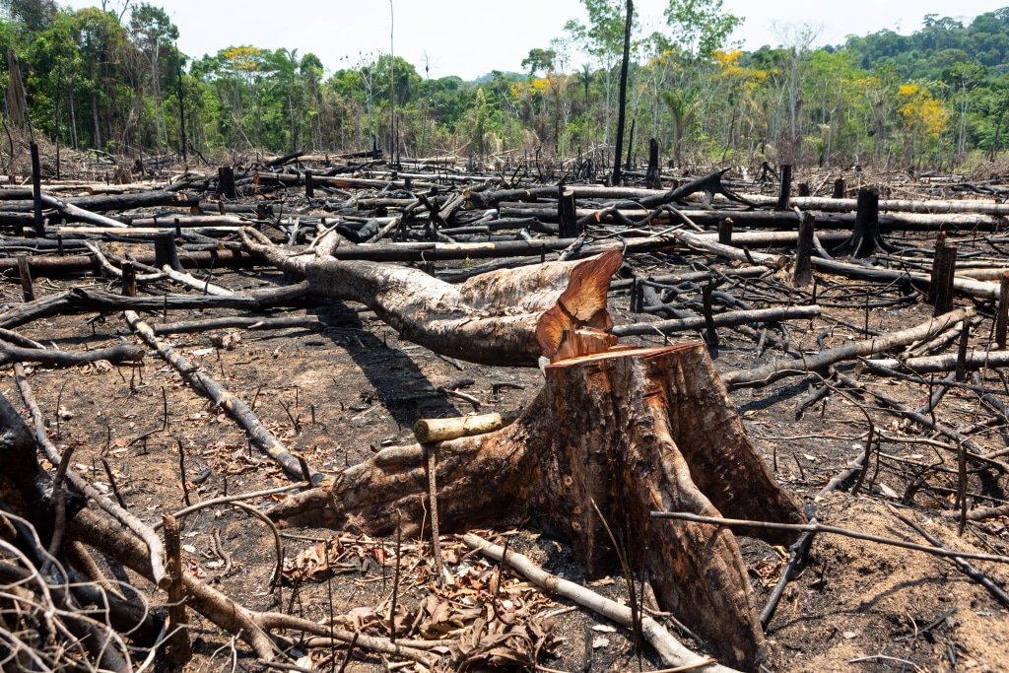 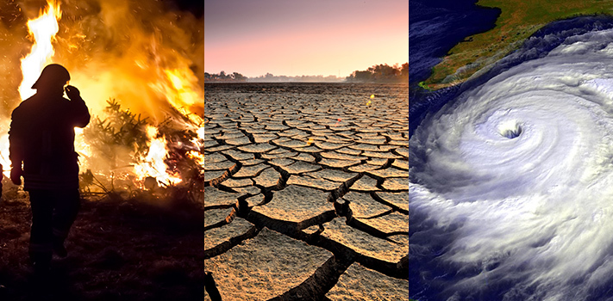

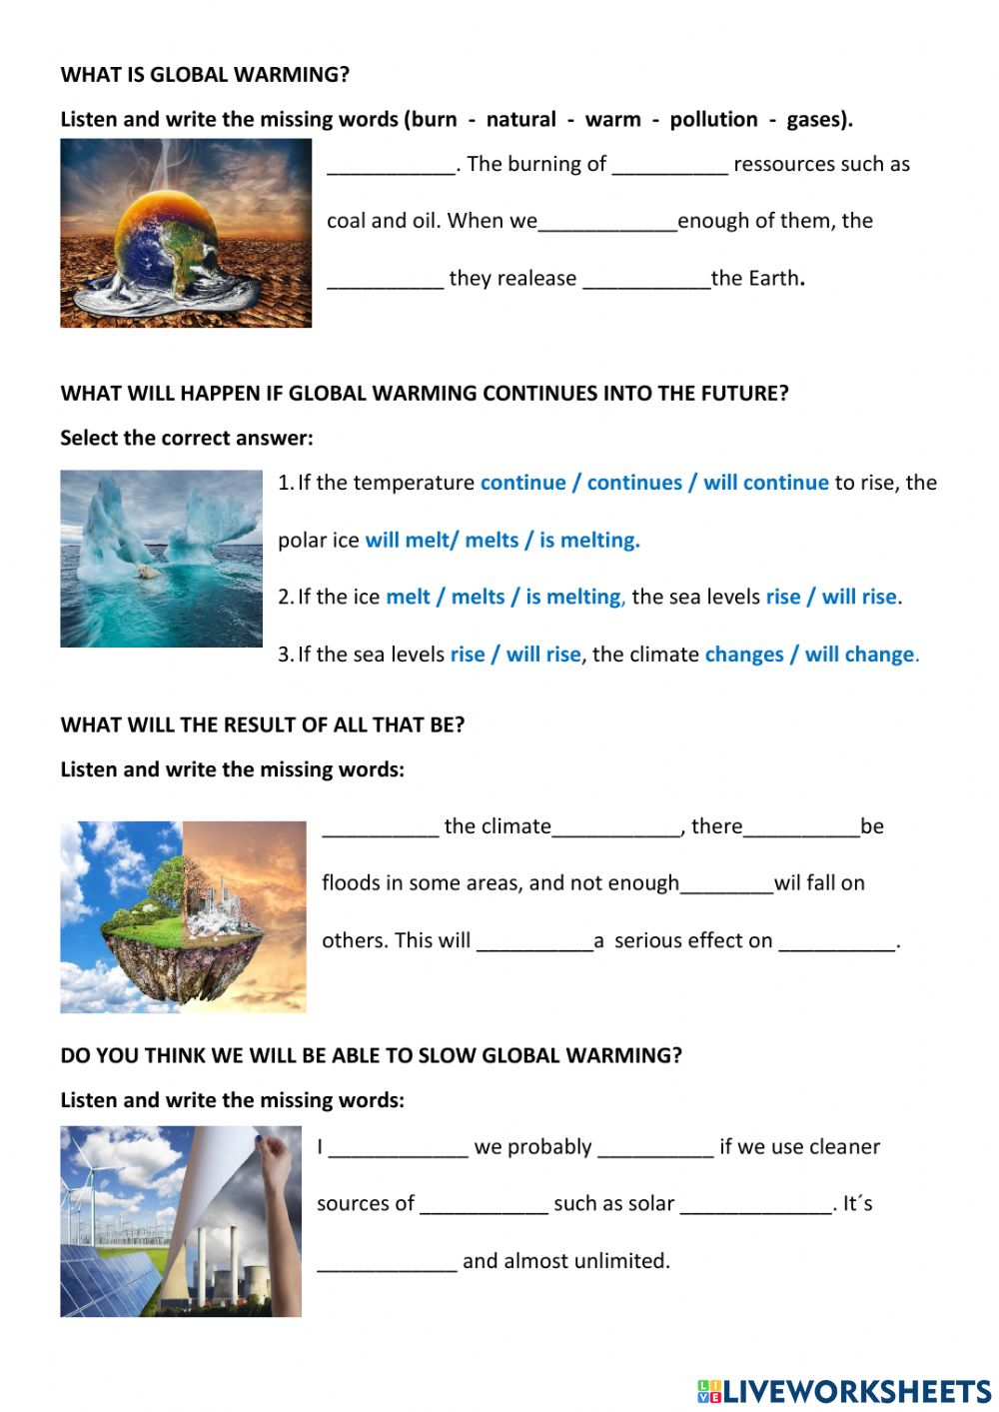

Exercise 3 put the correct answer{ yangi so’zlarni yozilish formatini va manosini yaxshilab mustrahkamlash uchun ushbu mashq keltirldi.}

Wrap up : Time is up with actions showing the hand and watch 2 times

We are free shake the hands and jumb 2 times then hug each other for give energy and motivation.

Ushbu dars ishlanma : Rahimjonova Sitora 315 guruh talabasi tomonidan maxsus seminar topshirigi uchun tayyorlandi.